New Book to Keep!
Dear Kindergarten Parents,
We had a special guest in our classroom today. The United Way of Putnam County has a program called “Real Men Read.” Kindergarten students throughout our county will have 6 visits this school year with volunteers to read to our class.
Each child will receive a free book to keep. Today’s book is titled, Wemberly Worried.
We enjoyed having someone new read to us today, and hope that you will enjoy the book with your family.
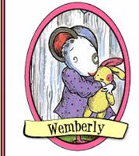
Read every day!

